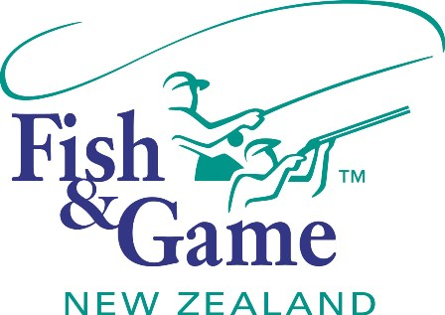
FISH & GAME N.Z -WEST COAST REGION
COUNCIL MEETING
TO BE HELD ON WEDNESDAY 15th JUNE 2016 AT THE
SENIOR CITIZENS HALL - WESTPORT- AT 7:00P.M.

AGENDA

- Welcome.
- Apologies.
- Agenda.
(Agree on Agenda)
- Conflicts of interest.
(Councilor recognition of agenda items in conflict with declared interests.)
- Accumulative Action List.
(Revision and update of spreadsheet.)
- Minutes of the previous meeting.
(Approval of previous meetings circulated and corrected minutes)

- Council Meetings.
(Set council meeting dates)
- Correspondence.
(Receive the correspondence)
- Financial Report.
(Receive the financial report.)
- Manager’s Report.
(Receive the managers’ report.)
- N.Z. Council Report.
(Receive the NZ Council report)
- 2016/17 Operational Workplan. (supplementary report)
(Adopt reviewed and amended draft Operational Workplan)

- Sportsfish and Game Management Plan Review. (supplementary report)
(Internal review to ascertain if a notified plan change is required to implement the new council’s goals)
- Governance Policies Review. (supplementary report)
(Internal review to ascertain if change is required to implement the new council’s goals)
- Private use of Fish and Game boat. (Andy Harris)
- Public Forum. (If requested)
(An opportunity for members of the public to express views to the council)

