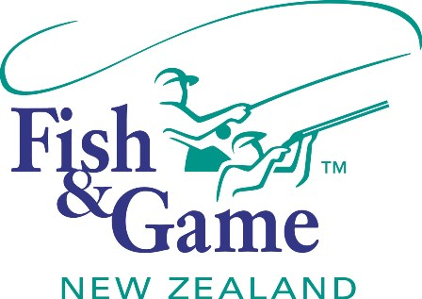
FISH & GAME N.Z -WEST COAST REGION
COUNCIL MEETING
TO BE HELD ON WEDNESDAY 20th JULY 2016 AT THE
ASHLEY HOTEL – GREYMOUTH - AT 7:00P.M.

AGENDA

The meeting will be preceded with a light supper at 6:30am. Councilors and members of the public are invited to discuss Council issues.

- Welcome.
- Apologies.
- Agenda.
(Agree on Agenda)
- Public Forum
(Invitation for public to speak)

- Accumulative Action List.
(Revision and update of spreadsheet.)
- Conflicts of interest.
(Councilor recognition of agenda items in conflict with declared interests.)
- Confirmation of previous meetings Minutes.
(Approval of previous meetings circulated and corrected minutes)

- Financial Report.
(Receive the Managers Financial Report.)
- Operational Report.
(Receive the Managers Operational Report.)
- Health and Safety.
(Mark Smith to facilitate discussion of Health and Safety)
- Personnel Policy.
(Revision and adoption of new policy)
- Governance Policies.
(Revision of Governance Policies)
- Questions.
(Questions from Councilors to the Chair, or from Councilors to Staff through the Chair)

