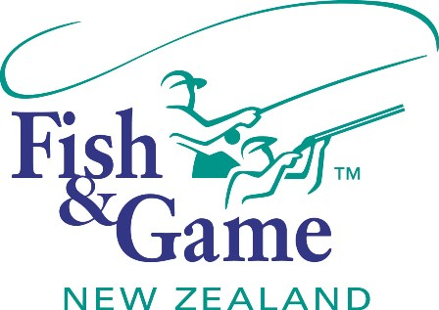
FISH & GAME N.Z -WEST COAST REGION
COUNCIL MEETING
TO BE HELD ON TUESDAY 14th FEBRUARY 2017 AT THE BRIDGE CLUB ROOMS, 12A LYNDHURST STREET, WESTPORT @ 7:00PM.

AGENDA

The meetings will be preceded by a light supper at 6:30pm.

- Welcome.
- Apologies.
- Agenda.
(Agree on Agenda)
- Public Forum
(An opportunity for the public to speak and answer questions.)
- Declaration of interests.
- Conflicts of interest.
(Councilor recognition of agenda items in conflict with declared interests.)
- Accumulative Action List.
(Revision and update of spreadsheet.)
- Minutes of the previous meeting.
(Approval of previous meetings circulated and corrected minutes.)
- Correspondence.
(Receive and provide responses to the correspondence received.)
- Financial Report.
(Receive the Financial Report.)
- Operational Report.
(Receive the Operational report and Game Harvest Survey report.)
- Health and Safety Report.
(Receive the Health and Safety report.)
- Health and Safety
(Mark Smith to provide an overview)
- NZ Council Report.
(Receive the NZ council report.)
- Game Issues.
(Andy to facilitate discussion on issues with feedback for incorporation into the 2017/18 workplan)
- Workplan and Budget Review.
(Review previous year and provide feedback to Manager for workplan and budget preparation)

